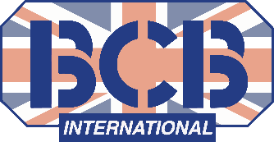
C05010 Rations 2022-05-04.docx 1000 KCAL
BCB International Ltd
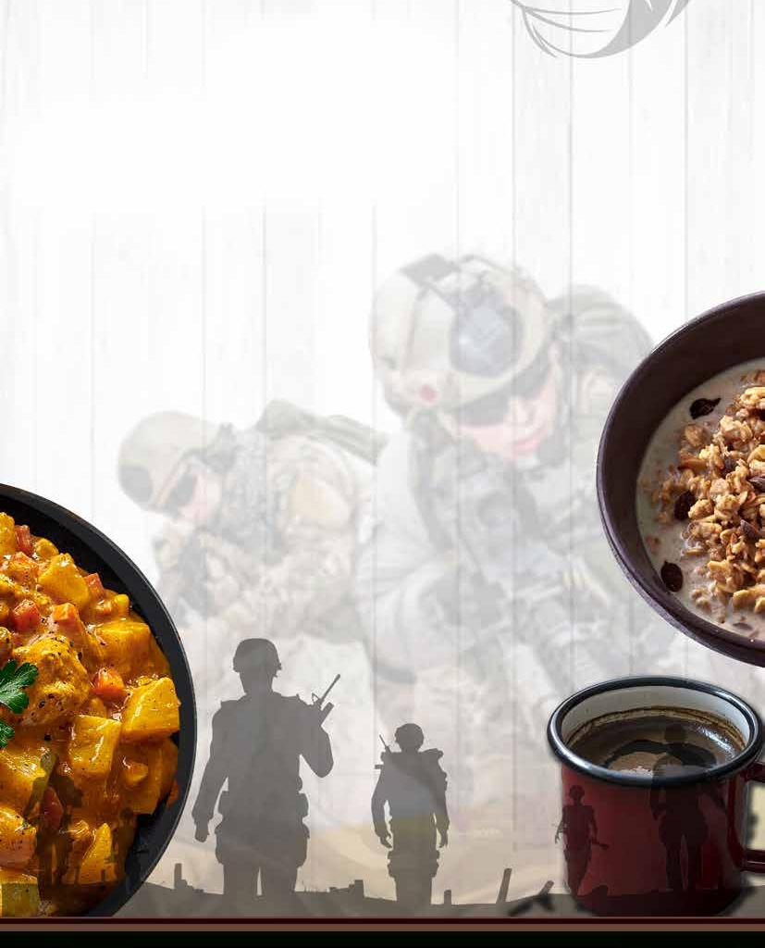
RATION OPTIONS

1,000 KCAL

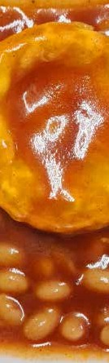
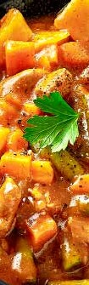
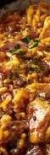
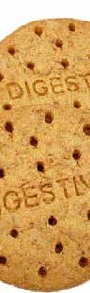
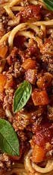

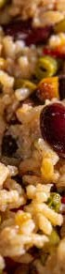

TEL +44 29 2043 3700
EMAIL INFO@BCBIN.COM

Specifications and contents may vary
BCB terms and conditions apply

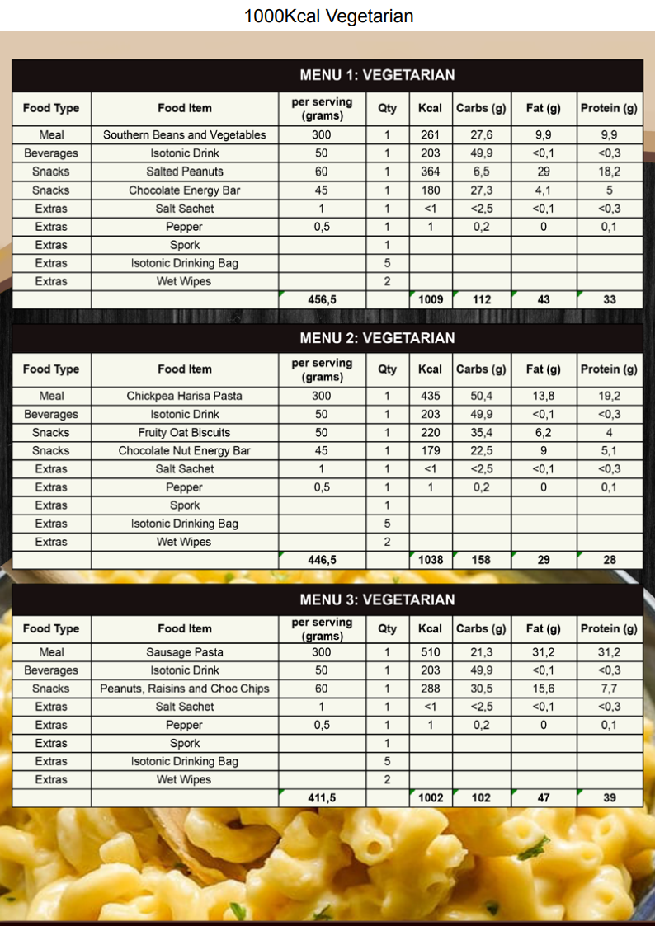

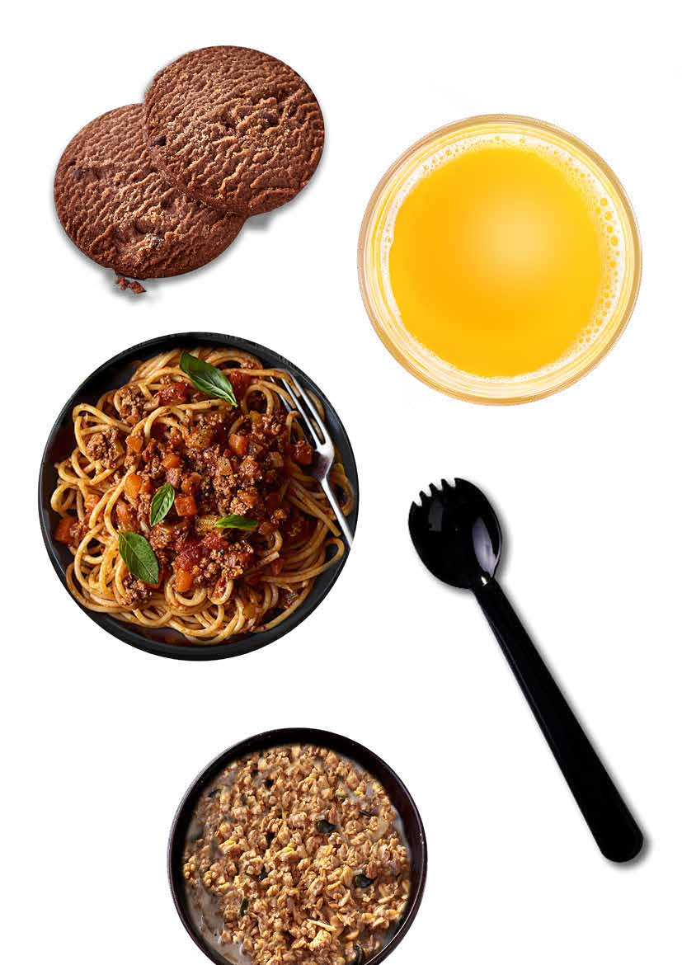
BISCUITS

ISOTONIC DRINK

MAIN MEAL SPORK

MUESLI BREAKFAST

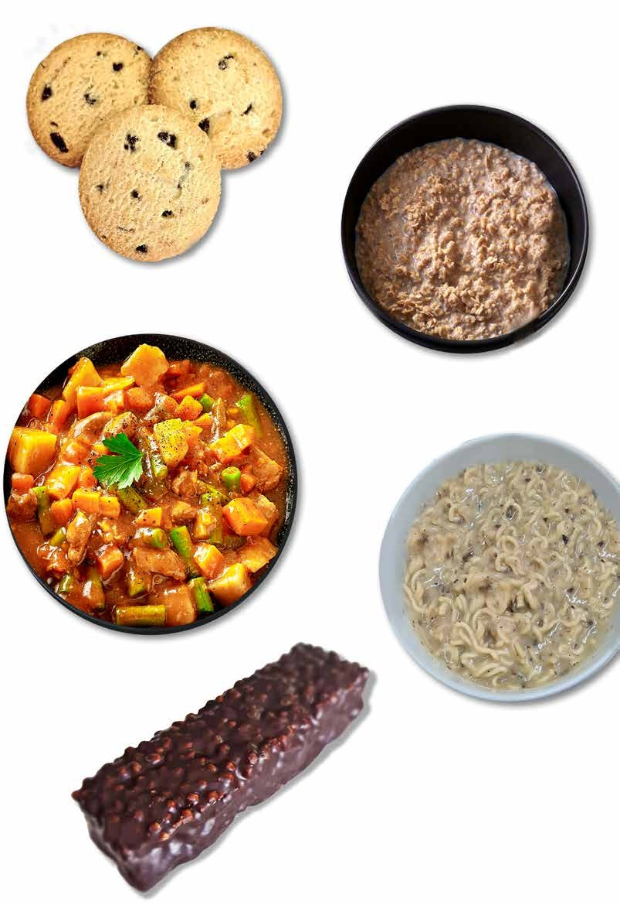
CHOCOLATE CHIP BISCUITS

VANILLA & BANANA OATS PORRIDGE

MAIN MEAL

INSTANT NOODLE MEAL

CHOCOLATE PROTEIN BAR

